**January School Newsletter**



Hello! Happy New Year and welcome back! We hope you all had a wonderful Winter Break and are ready for all the exciting things the new year is sure to bring. Here’s a look at how January is unfolding here at Frank Hobbs …

**2023-2024 Frank Hobbs School Bell Schedule:**

* Start time 8:45 am
* Recess: 10:15-10:30
* Lunch: 11:50-12:10 (eating) 12:10-12:35 (recess time)
* Dismissal: 2:37 pm
* Attendance is 250-477-1804 (press 1) or [FHAttendance@sd61.bc.ca](mailto:FHAttendance@sd61.bc.ca) ***Please remember to use your child’s first and last name.***

**Reminders:**

* **Professional Development Day** is Friday, January 26th*, there is no school for students*.
* Our pull-through drop off area is a loading zone, and **not for parking *at any time****.*
* We also ask that before and after school, children do not congregate on school playgrounds as there is no school supervision.

**Report Cards:**

If you are having difficulties accessing your child’s report card online through Parent Connect, please let your teacher know when we return to school on Janury 8th.

**Library News:**

Just a friendly reminder to please take care of your books over the Winter Break, and then to return them to Ms. Ruck on time. Thanks!

**Health and Safety:**

Helpful Links:

Communicable Disease Update:

[Communicable Disease Update](https://frankhobbs.sd61.bc.ca/wp-content/uploads/sites/52/2022/11/communicable-disease-update-november-18-2022.pdf)

**Daily Health Checklist:**

As the weather gets colder, we thank you for performing a daily health check with your child (the link is on our school website). The process is very important as it helps to keep us all healthy, and helps to stop the spread of Covid 19, colds and the flu. Therefore if after doing your daily health check you determine that your child(ren) is sick, please keep them at home until they are well enough to attend classes.

[Head Lice - Updated Information for Families](https://frankhobbs.sd61.bc.ca/wp-admin/upload.php?item=6221#:~:text=https%3A//frankhobbs.sd61.bc.ca/wp%2Dcontent/uploads/sites/52/2022/11/Head%2DLice%2DManagement%2DGuidelines%2DWH%2DPDF.pdf) (this link is simply for your information)

And remember, our [Frank Hobbs School Website](https://frankhobbs.sd61.bc.ca/) has links to not only our Daily Health Checks for Parents, but also updated District Health and Safety Information, Parent Connect, School Cash Online, the School Calendar, student artwork, staff contact information, and much more!

**School Cash Payments Online:** If you need to make a payment, please go to our [Frank Hobbs School Website](https://frankhobbs.sd61.bc.ca/) under Quick Links! Thank you so much.

**Dance Club Update:**



**1000X5 =** 1000 Books by Age Five

Children’s Book Recycling Project Greater Victoria - **Bring on the Books!**

The 2024 year has begun and 1000X5 volunteers are into Year 12 of sorting and delivering the 250,000 books for babies and preschoolers which have been so kindly donated by you. Every month we send 2500-3000 books into homes with few resources.

Thanks for your donations of books to this wonderful program. We have a collection bench for your book donations in our front entryway.

**Important Upcoming Dates**:

* January 8th: First Day Back from Winter Break
* January 12th: Pac Romeo Pasta Day (last day to order was Dec 22)
* January 25th: PAC Popcorn Day (last day to order was Dec 22)
* January 26th: Professional Development Day – no school for students
* January 29 – Feb 2nd: Late Immersion French Registration Week
* January 29th – February 2nd: Kindergarten Registration Week
* February 9th: PAC Calzone Day (last day to order was January 19)
* February 12-16th: K to Gr 12 Student Transfer Process Week and All New Grade 1–12 registrations for the September 2024/2025 school year
* February 16th: Professional Development Day – no school for students
* February 19th: Family Day Stat holiday
* February 23rd: PAC Subway Day (last day to order was January 19)
* February 28th: Pink Shirt Day and assembly
* March 18 – April 2nd: Spring Break
* April 3rd: First day back after Spring Break

**Weather and Outside Time**

Please remember to dress your kids for the weather – we go outside rain or shine!



***Welcome to 2024 – we hope it’s a happy and healthy year ahead for you all!***

Ingrid Fawcett, Principal ~ Ramy Gerber, Vice Principal

Kealy Hansen, Administrative Assistant



________________________________________________________________________________

And now….

**Frank Hobbs PAC News!**

**January 2024 PAC newsletter**



6:30 pm to 8 pm January 18, 2024

Where: Frank Hobbs library, in-person

Need childcare in order to attend? We will host a few kids to facilitate parent attendance and meaningful engagement.

Contact PAC Vice President, Lindsay Coulter, to reserve a kid spot [frankhobbselempac@gmail.com](mailto:frankhobbselempac@gmail.com)

The agenda will be circulated 7 days prior. Want to suggest an agenda theme or topic? Email the PAC Exceutive at [frankhobbselempac@gmail.com](mailto:frankhobbselempac@gmail.com)

**HOT LUNCH INFORMATION** 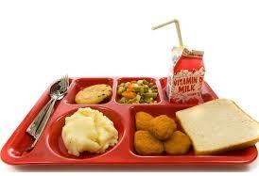

**Last day** to place orders for January hot lunches was December 22 by 3pm. Sorry late orders can not be accepted as deadlines are placed by vendors. If orders aren’t paid by this date, they will be removed from your account.

**February's hot lunch deadline is Jan. 18 by 3 pm!**

Look forward to:

**January 12 Romeos pasta - *PACK A FORK OR SPOON please!***

**January 25 popcorn day**

**February 9 Calzone**

**February 23 Subway**

**We need volunteers!**

Can you help organize and deliver food to classes on hot lunch day, and/or Fruit and Veggie day? Click the volunteer box under the order date when you place lunch orders. Volunteers are contacted a few days prior with details. We need 10+ parents to help from 1130am-12:15pm in order to run. Fruit and Veggies times are from 8am-10am. Please sign up for one or more throughout the year!

EVEN IF YOU ARE NOT PLANNING TO PLACE LUNCH ORDER THIS YEAR PLEASE STILL CREATE AN ACCOUNT FOR YOUR CHILD. The PAC uses this platform for important dates and information such as fun activities we put on and fundraising activities. Please follow the link below to set your account.

<https://frankhobbs.hotlunches.net/admin/>

COMMUNITY NATURE RESTORATION EVENT in HARO WOODS

**Sunday 11:00 am-12:30 pm, January 7th**

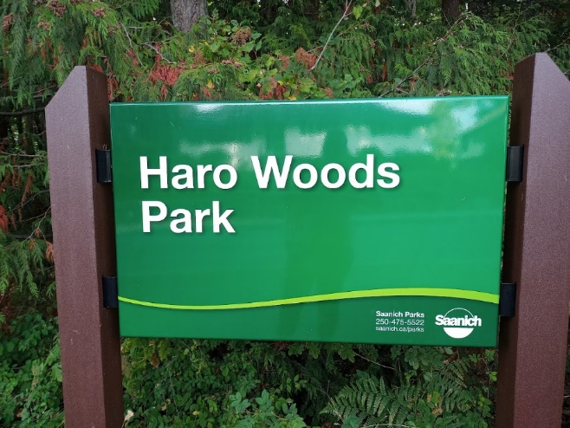

Everyone is welcome to volunteer in our local Haro Woods! Join Saanich’s Lead Steward, Lindsay Coulter, to pull invasive English Ivy. Build a connection with the land, get your Vitamin “N” for nature and help the native plants thrive once again.

**Where**: Meet at Eagle Rock (giant boulder off Finnerty Road inside the woods). Parking is free in the UVic daycare lot or take the #11 bus.

**When**: January 7th from 11 am -12:30 pm

**What**: Bring a water bottle and garden gloves. Lindsay will also provide adult and kid-sized gloves.

**Note**: The event will run rain or shine. Snow or high winds would cause a cancellation. There is no washroom on site. RSVP to [lindsayjoycoulter@gmail.com](mailto:lindsayjoycoulter@gmail.com)