**November School Newsletter**



November is the month when we recognize Rememberance Day, and we turn our clocks back one hour to Standard Time. This is what November looks like here at Frank Hobbs …

**2022-2023 Frank Hobbs School Bell Schedule:**

* Start time 8:45 am
* Recess: 10:15-10:30
* Lunch: 11:50-12:15 (recess) 12:15-12:35 (eating time)
* Dismissal: 2:37 pm
* Attendance is 250-477-1804 (press 1) or [FHAttendance@sd61.bc.ca](mailto:FHAttendance@sd61.bc.ca) (late or absent) ***Please remember to use your child’s first and last name, thanks!***

**Rememberance Day is Friday November 11th, and Professional Development Day** **is Monday November 14th*,*** *there will be no school for students on those days*.

**Welcome to our new Staff:**

* Tess Kidd, ELL
* Caela Allaby, Learning Support
* Christine Jones, Learning Support
* Andrew Fortune and Sam Glowicki, Student Teachers
* Crystal Kerr, EAG

**Rememberance Day Poppy Drive**

Every year, from the last Friday of October to November 11, tens of millions of Canadians [wear a Poppy](https://www.legion.ca/remembrance/the-poppy/how-to-wear-a-poppy) as a visual pledge to honour Canada’s Veterans and remember those who sacrificed for the freedoms we enjoy today.

While the Poppy is distributed freely to all who wish to wear one, the Legion gratefully accepts donations to the Poppy Fund. At Frank Hobbs, we also recognize the sacrifices made by our past and present member of our Armed Forces – Click [here](https://legion.ca/donations) to donate to the Royal Canadian Legion’s Poppy Drive. The monies collected provide financial assistance and support to Veterans, including Canadian Armed Forces and RCMP, and their families who are in need. Thank you for your support, the poppy you wear, shows them you care.



**Student Opportunities:**

We are pleased to be able to offer the following opportunities for our students:

* Dance Club – grades 2/3 and 4/5 (Elyse Thorburn)
* Soccer – grades 4/5 (Peter Ellison and Sam Glowiki)
* Cross Country – grades 3-5 (Tracy Johns)

*It was great to see over 40 students participating in cross country, way to go team! City Finals are the afternoon of Nov 4th. Information will be sent home to parents.*

* Spirit Club – grades 4/5 (Lancy Fynn)
* Library Monitors and Lunch Monitors – grades 4/5 (Ramy Gerber and Lancy Fynn)
* PAC Swim Club – run by our wonderful PAC volunteers

**(And thanks to our PAC for putting on Family Game Night, it was a lot of fun and a big success!)**

*to our fabulous staff and PAC for volunteering their time and*

*energy to run our clubs & athletics! We appreciate all you do!*

**Sock-tober Sock Collection**

Thank you to everyone for your sock donations; your generosity will make a big difference to many folks in need this winter!

**Scholastic Book Fair:**

Continuing with the gratitude theme, thank *you* all so much for supporting the annual Frank Hobbs Fall book fair! With your support, our library raised over ***$4000*** for resources for our school!

**Our Frank Hobbs School Website**

We’re working hard to keep our website current, providing families with up-to-date information in all areas of school life. Please remember to please check out the [Frank Hobbs School Website](https://frankhobbs.sd61.bc.ca/) – for updated District Health and Safety Information, Attendance Logging, Classroom artwork, the Parent Connect, School Cash Online, school reminders, the School Calendar, Staff contact information, and much, much more! Thanks to our Admin Asst Kealy Hansen, for keeping us all entertained and informed!

**Chess Lessons:**

Lessons for those in Divisions 1-4 have commenced and students are now actively learning how to play this wonderful game. If you have not already done so, please pay for your child’s lesson fee online at [School Cash Online](https://sd61.schoolcashonline.com/).

**Parent Connect:**

Just a reminder to those parents who have not yet logged in to Parent Connect to review and consent to any applicable class access forms.

The link: [Parent Connect Sign In](https://parentconnect.sd61.bc.ca/Identity/Account/Login?ReturnUrl=%2F)

**Become A Host Family**

[Student Home Stay Information for Families](https://frankhobbs.sd61.bc.ca/wp-content/uploads/sites/52/2022/10/VIE-Host-Family-Mini-Poster.pdf)

**Library Books:**

Ms. Fynn has kindly asked that you please return your library books on time. Thanks!

**Health and Safety:**

As the weather gets colder, we thank you for performing a daily health check with your child. The process is very important as it helps to keep us all healthy, and helps to stop the spread of Covid 19, colds and the flu.

Link to K-12 Daily Health Check App

<https://www.k12dailycheck.gov.bc.ca/healthcheck?execution=e1s1>

[Information in Head Lice](https://www.healthlinkbc.ca/healthlinkbc-files/head-lice)

Weather and Outside Time:

**With the stormy, wet weather moving in, our school playgrounds are only going to get muddier - please send your child(ren) to school with INDOOR SHOES so we can keep our classes and hallways clean.**

Please dress your kids for the changing weather - at Frank Hobbs we go outside rain or shine!

**Holiday Craft Fair: A message from Campus View Elementary:**

We are so excited to share that Campus View Elementary School is hosting a *Holiday Craft Fair,* after a two year pause.

The Fair will take place on Saturday, December 10th, 2022 from 11 am to 3 pm.

We are reaching out to students who may be interested in participating as a vendor or volunteer.

We would like to invite you to apply for a table:

* Youth vendor table:$10
* Adult vendor table: $35

Tables are secured with payment on a first come first served basis. While we try to accommodate specific requests, we cannot promise a specific location for your table.

If you would like to apply for a vendor table, please email [campusviewcraftfair@gmail.com](mailto:campusviewcraftfair@gmail.com) with the following information:

~~~~~~~~~~~~~~~~~~~~~~~~~~~~~~~~~~~

Name:

Address:

Phone number:

Product (What are you selling? Please include a photo or two):

Number of tables:

Are you bringing your own table? (Y/N)

Do you need power? (Y/N)

Door Prize:

(Please note we ask vendors to donate a door prize item. Please submit on the day of the event. We are happy to provide a donation in kind receipt for business purposes.)

~~~~~~~~~~~~~~~~~~~~~~~~~~~~~~~~~~~

Campus View Families host a bake sale. If you have baked goods, please email [campusviewcraftfair@gmail.com](mailto:campusviewcraftfair@gmail.com) for further discussions.

Campus View PAC will pay for advertising in the Times Colonist and promote the event through Facebook and community posters. When the poster is ready, we can provide you with a PDF version if you too would like to circulate it.

We are very excited to recommence this wonderful and fun family event. Thank you for your interest in joining our community event.

Warm regards,

Ann

Campus View Elementary PAC, Vendor Coordinator

**Lost and Found:**

Our lost and found is bursting at the seams! There are many sweatshirts, sweaters, and jackets, especially in smaller sizes.  If your student is missing clothing, please remind them to look in the lost and found closet to claim any missing or lost items.

**School Cash Payments Online:**

If you have not yet done so, please remember to pay for your Agenda Planners or field trips, on the [Frank Hobbs School Website](https://frankhobbs.sd61.bc.ca/) Thank you so much.

**1000X5 = 1000 Books by Age Five**:

Children’s Book Recycling Project Greater Victoria - **Bring on the Books!**

The 2022-2023 year has begun and 1000X5 volunteers are into Year 12 of sorting and delivering the 250,000 books for babies and preschoolers which have been so kindly donated by you.

Every month we send 2500-3000 books into homes with few resources. Thanks for your donations of books to this wonderful program. We have a collection bin/bench for your book donations in our front entryway.

**Important Upcoming Dates**:

November 4th: Cross Country City Finals – 12:30pm at the former UVic dog walk park

November 4th: PAC Popcorn Day (last day to oder is Oct 24th)

November 6th : Daylight Savings ENDS – remember to turn your clocks back one hour

November 10th : PAC Pizza Day (last day to order is Nov 1st)

November 10th: Rememberance Day School Assembly

November 11th : Rememberance Day:– school not in session

November 14th : Pro-D Day:– no school for students

November 25th : Fun Hair Day

December 16th: PAC Popcorn Day and the last day of classes before the Winter Break

January 3rd: First Day Back from Winter Break

__________________________________________________________________

**Frank Hobbs PAC News!**

Next Meeting: Wednesday Nov 16th @8pm

Join Zoom Meeting here: <https://us06web.zoom.us/j/87231667425?pwd=QnhyMFBCNjlOZlVESE1VTDJVRUJzZz09>

**Purdy's Christmas Chocolate Fundraiser**



Our annual Christmas fundraiser with Purdys is live until **November 27th**. Order chocolates through Purdy's and we receive 25% back to our school! Visit <https://fundraising.purdys.com/1371934-95604> to complete your registration and get your holiday treats. Our campaign number is **42603**. Be sure to share with family and friends. Pick up is scheduled for Dec 9th, but likely sooner depending on shipping. Please contact by email if you need to make alternate pick up arrangements. Thank you for supporting our PAC!

**PAC Family Game Night Review**

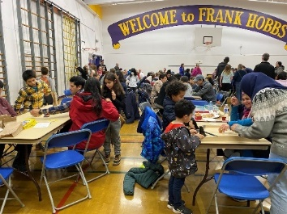

On Oct 28th we hosted our very first Family Game Night. We had over 200 people attend and was a huge success that raised money for our PAC supported programs.

Congratulations to the grade 5 volunteers who showed up with enthusiasm and worked hard to raise money for their Salish Sea School Afloat field trip. Well done, grade 5 student volunteers! An especially big THANK YOU to our event sponsor, Megan Kritzinger, who made it all come together, along with all other parent volunteers - and thank you to all the families who came out to connect, support and revitalize our school community!

**Bottle Donations**



Caddy Bay Liquor Store donates bottle return to our PAC. If you can help support us by **volunteering to collect bottles 1x every month or two** (less if there are more bodies!), please email Jenny at [jennynanninga@gmail.com](mailto:jennynanninga@gmail.com). The time commitment would be roughly 1-1.5 in total per collection. All bottles are clean, counted, and boxed. The task is as simple as transporting. We currently have some volunteers but need more to spread out the workload. Thank you for considering! Our PAC also has a charity account at all bottle depots: Frank Hobbs PAC if you donate your own bottles at any Return-It stations.

**School Spirit Wear**

This year our very own, and very talented Beth Campbell, who is a Frank Hobbs parent and AND former student, is working in partnership with other parents to bring a newly designed spirit wear hoodie to our school! More information with design and how to order will be sent out this week.

**Hot Lunches**

Thank you to all our volunteers who helped hand out booster juice on October 20, it was very well organized by our Hot Lunch Coordinator - Thank you, Elaine! Many of the students enjoyed the tasty treat! Popcorn day is November 4 and ordering is now closed. The last day to order for November 10th's pizza day is November 1st. Please place and pay your child's orders on the hot lunch site here: <https://frankhobbs.hotlunches.net/admin>/

Any families who have not already reached out and would like to take part but need assistance with paying, please contact [lunches@frankhobbspac.ca](mailto:lunches@frankhobbspac.ca) - inquiries will be completely confidential.

**Take Me Outside Day - Summary Report**

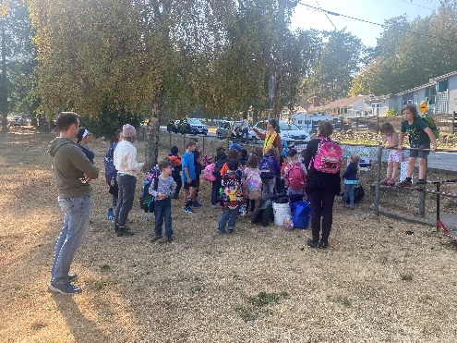 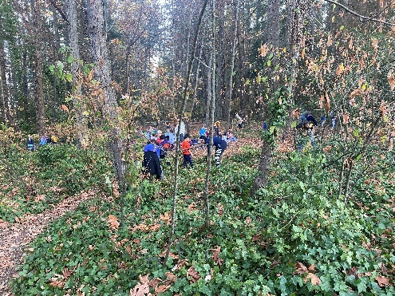

Thirty six Frank Hobbs kids and parents enjoyed a dose of Vitamin "N" for nature on #TakeMeOUtsideDay. Saving our native plants from invasive English ivy mitigates the adverse effects of climate change we witness each day. Haro Woods acts as our local lungs, shades us during heat domes and drinks the rain up during atmospheric rivers.

Thank you, Lindsay Coulter, volunteer Lead Steward for Saanich and Frank Hobbs parent, and everyone who took part.

**Upcoming  Movie Night (Date TBD)**

We are excited to announce that we’ll be hosting a Frank Hobbs movie night in late November or early December! The movie will be shown in the Frank Hobbs gym, and will be appropriate for all grades. We look forward to sharing a movie and some popcorn together. Entry will be by suggested donation of $5 or more per family, will include popcorn and pizza will be sold by the slice for $4.

Stay tuned for more details, and if you have any great movie suggestions, please come to the Nov 16th meeting and let us know!

**School Garden Beds**

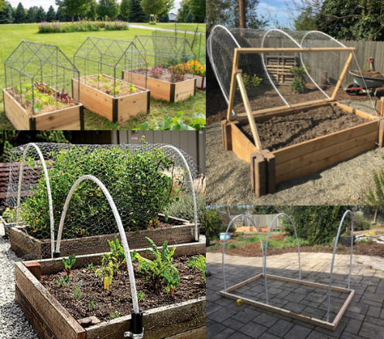

Have you noticed the extra garden beds at the front of the school? We will be doing some winter garden planting and would love some help making a cover. If you have any extra supplies - plastic or metal wire, bracket pieces, or flexible pvc piping similar to photo and/or if you have some time to spare - please let us know!

**Swim Club**

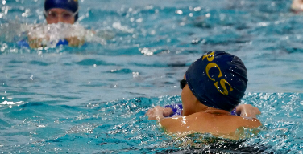

Frank Hobbs Swim Club had their first practice last Thursday at UVic. Registration is now complete and we are currently at full capacity for the program. Payments for registration fees and swim caps can be made through the hot lunch site here: <https://frankhobbs.hotlunches.net/admin>. Please contact swim club coordinator, Teresa Pitt, at [teresa.pitt@gmail.com](mailto:teresa.pitt@gmail.com) with any questions.

**School Fruit and Veg Program**

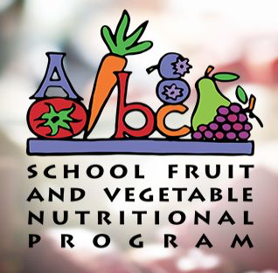

We are still looking for a coordinator for the BC Fruit and Vegetable Nutritional Program. This initiative sees fresh fruit and veggies delivered to every class once per month. More information can be found here: <https://www.bcaitc.ca/index.php/bc-school-fruit-vegetable-nutritional-program#overview> and please get in touch if you are interested in helping get back to Frank Hobbs!

Please reply to [jennynanninga@gmail.com](mailto:jennynanninga@gmail.com) for any PAC comments or questions. Thank you for your ongoing support of our PAC Executive.

Thank-you!

The Frank Hobbs PAC Executive

***Thank you for your support of the Royal Canadian Legion’s Poppy Drive - we here at Frank Hobbs hope you all have a wonderful month,***

Ingrid Fawcett, Principal ~ Ramy Gerber, Vice Principal

Kealy Hansen, Administrative Assistant

